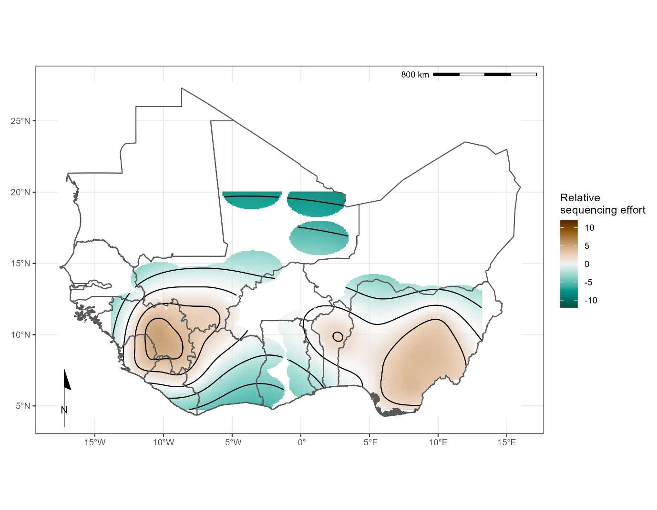

Supplementary Figure 1 – Modelled relative sequencing effort of combined human and rodent samples, adjusted for the number of reported confirmed cases in a region or country from 2012-2022. Greatest sequencing effort coincides with areas where sampling in humans (Edo, Nigeria and Kenema, Sierra Leone) and rodents (Faranah, Guinea) have historically been focussed.

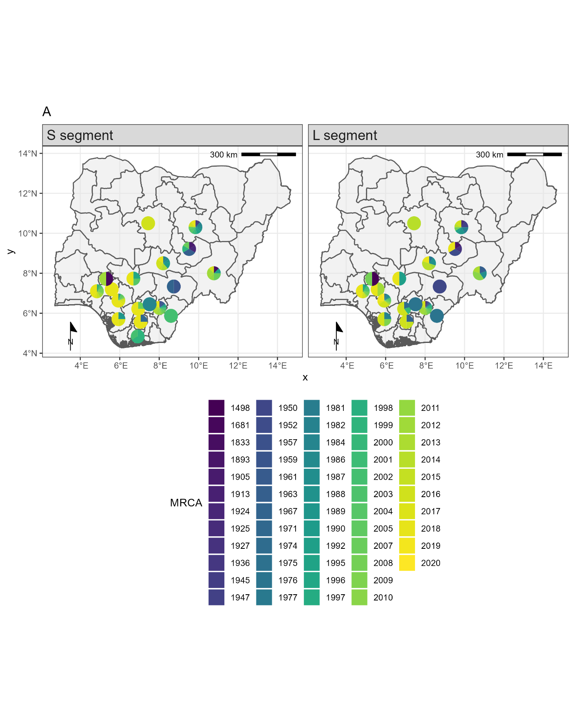

Supplementary Figure 2 – **A** Most recent common ancestor (MRCA) for included samples in phylogenetic analysis from Nigerian states for the S segment (Left) and L segment (Right). Colours in the pie charts correspond to year of MRCA for each individual sample.

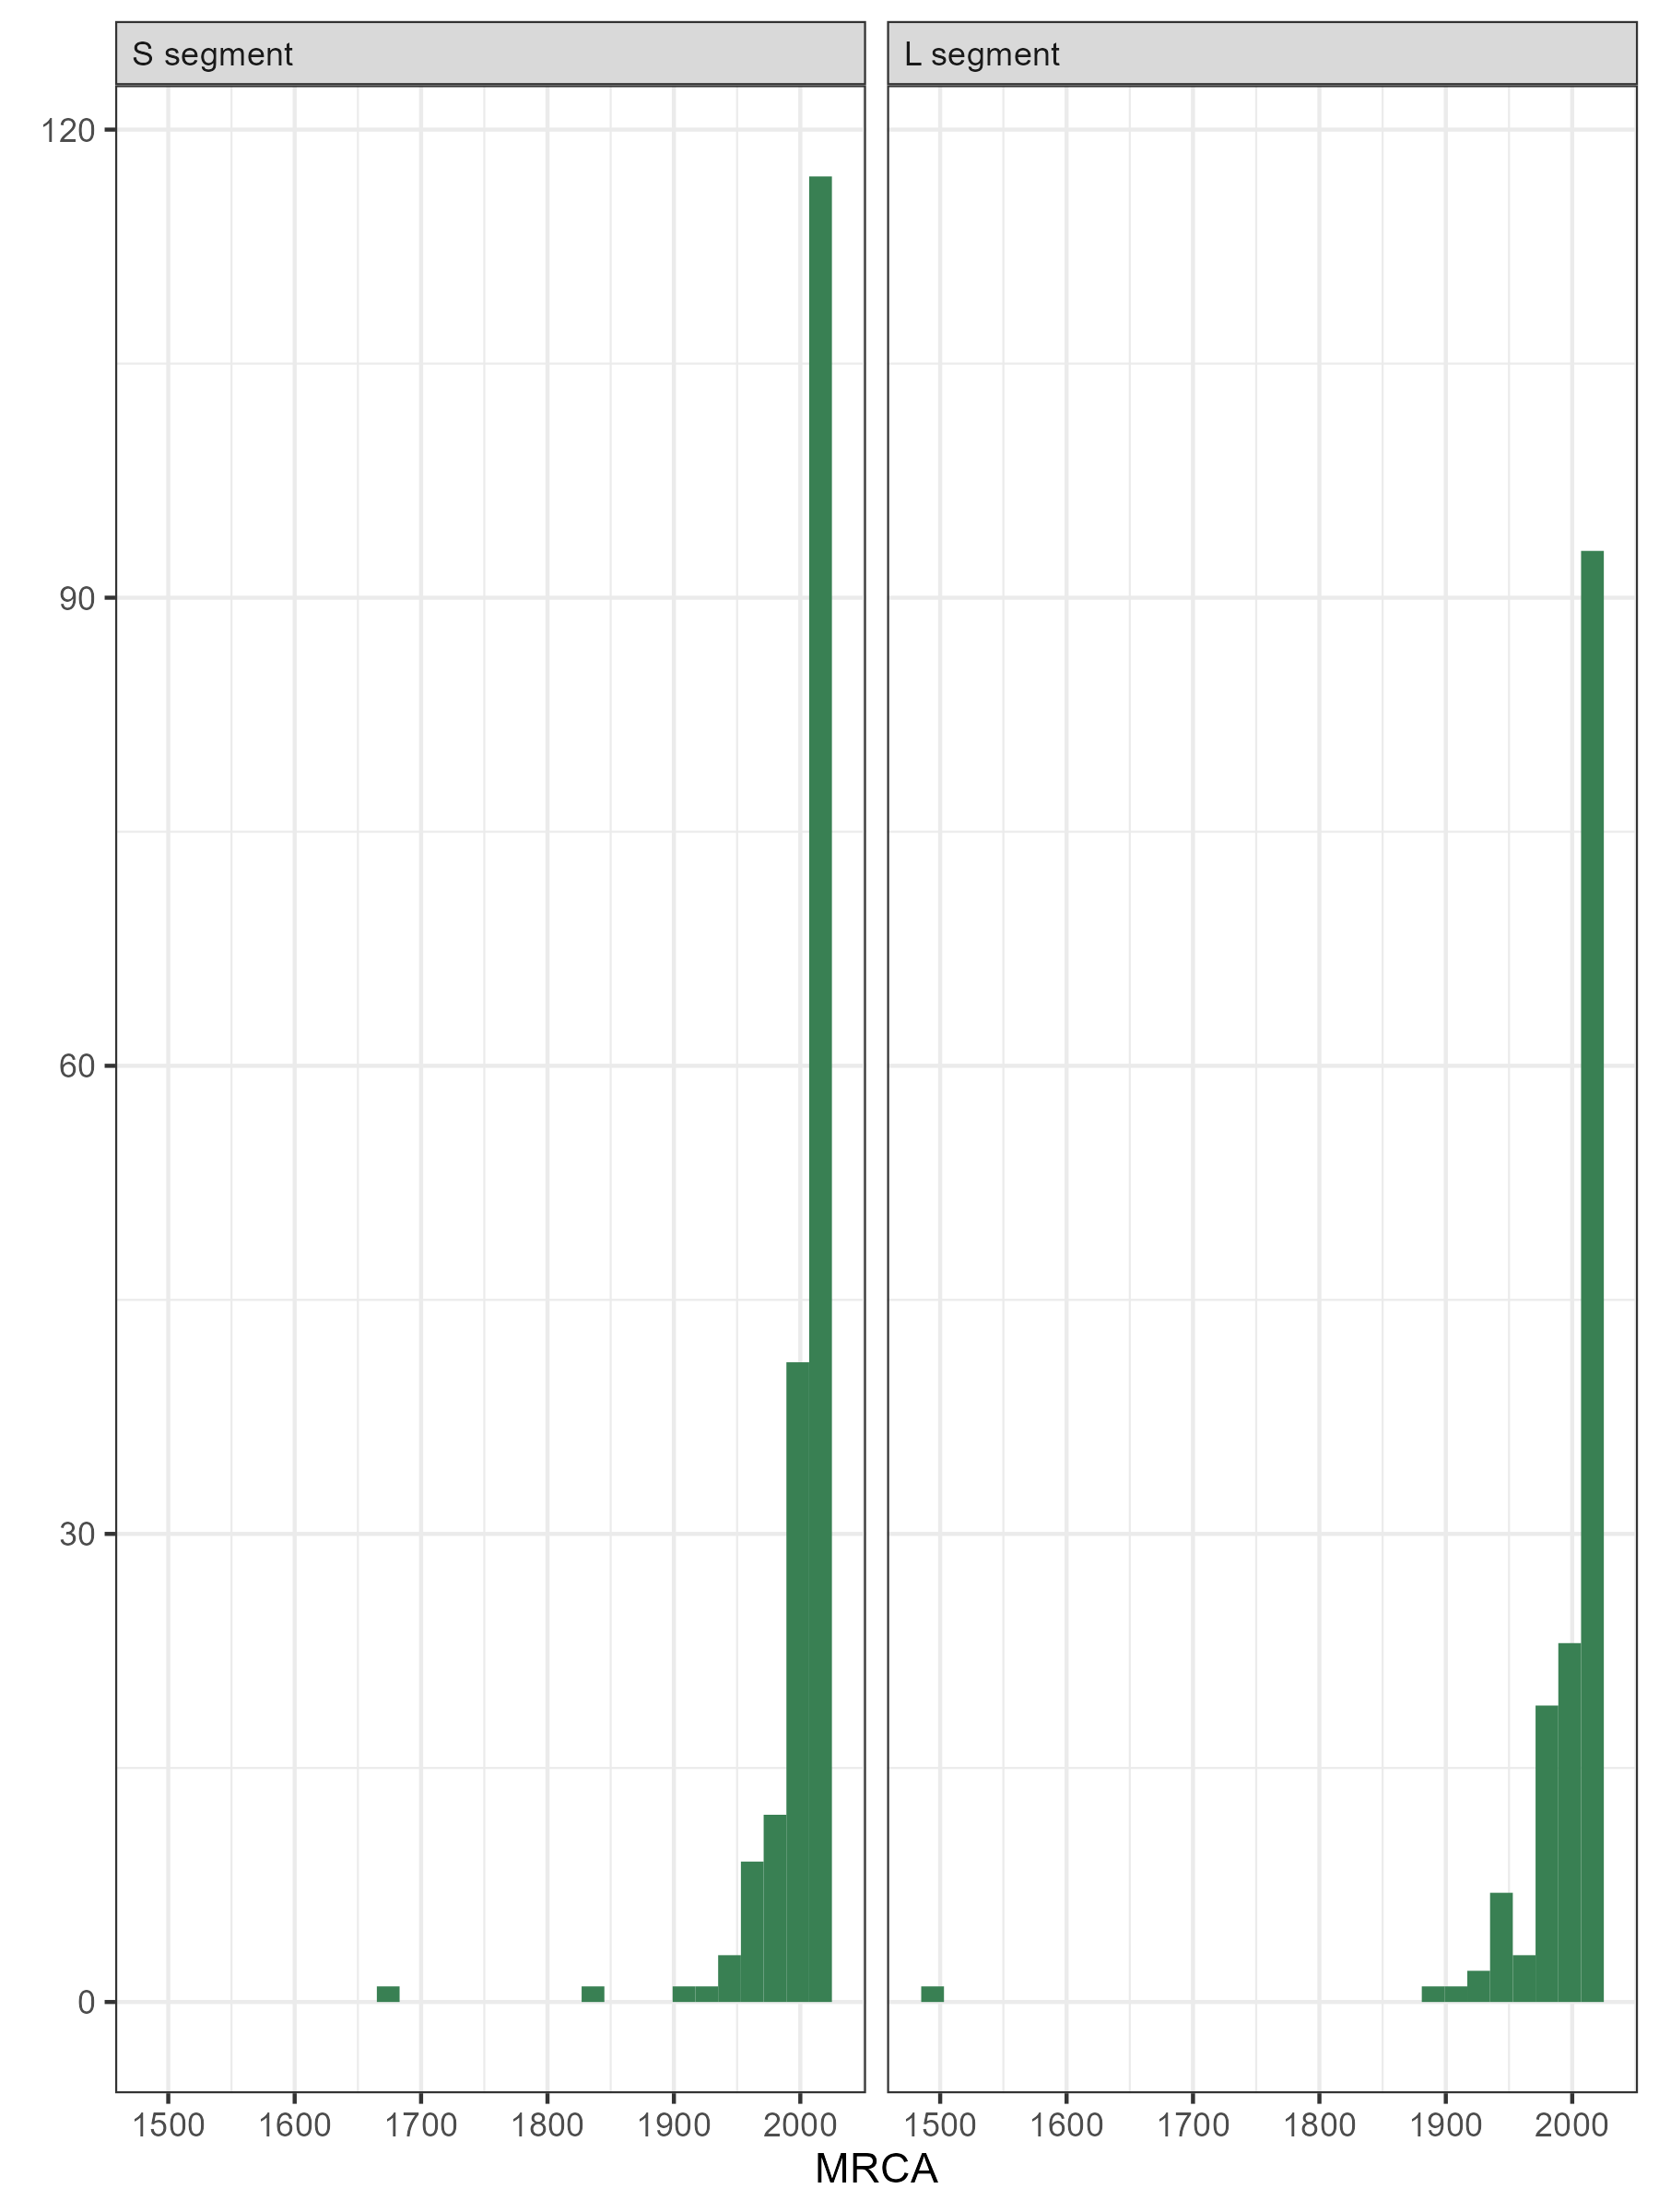

Supplementary Figure 2 – **B** Histograms of MRCA for included samples in phylogenetic analysis from Nigerian states for the S segment (Left) and L segment (Right).

Supplementary Figure 3 – Reference map of West Africa to support interpretation of figures.